**Project Design Phase-II**

**Technology Stack (Architecture & Stack)**

|  |  |
| --- | --- |
| Date | 03 October 2022 |
| Team ID | PNT2022TMID52101 |
| Project Name | Project - News Tracker |
| Maximum Marks | 4 Marks |

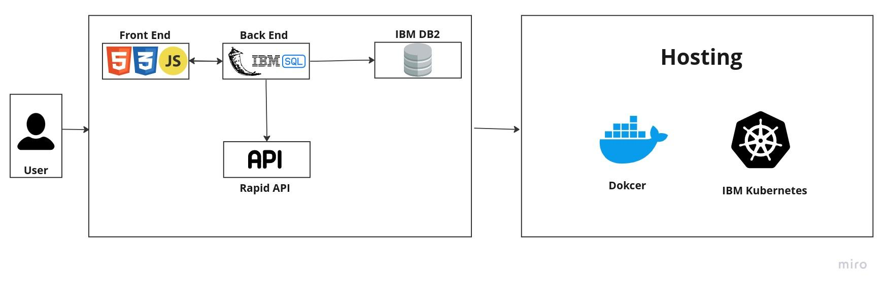

**Table-1 : Components & Technologies:**

|  |  |  |  |
| --- | --- | --- | --- |
| **S.No** | **Component** | **Description** | **Technology** |
|  | User Interface | How user interacts with application e.g.  Web UI, Mobile App, Chatbot etc. | HTML, CSS, JavaScript |
|  | User registeration | Registeration of the user to the app | Flask,Javascript |
|  | User Verification | Verification of the email | Sendgrid |
|  | User Login | Logs in the user to the App | Flask,Javascript |
|  | Database | Stores the user data in the database | IBM DB2 |
|  | External API | Fetch news from the API | News API from rapid API |
|  | Infrastructure (Server / Cloud) | Application Deployment on Cloud | Docker,IBM Kubernetes, etc. |

**Table-2: Application Characteristics:**

| **S.No** | **Characteristics** | **Description** | **Technology** |
| --- | --- | --- | --- |
|  | Open-Source Frameworks | Used for developing the backend | Flask |
|  | Security Implementations | Encrypts the user password,generate unique code for email verification,generate unique token for user login stored in cookie | SHA-256, Encryptions |
|  | Scalable Architecture | Coded in such a way such that it can scaled and reused later for upgrade | Clean code practices |
|  | Availability | The app should be available and loadable in all devices | CSS, IBM hosting |
|  | Performance | The app is designed in such a way that it uses small size images and less animation with minimalistic UI and UX | HTML,CSS,Javascript |

**References:**

[**https://flask.palletsprojects.com/en/2.2.x/**](https://flask.palletsprojects.com/en/2.2.x/)

[**https://docs.sendgrid.com/**](https://docs.sendgrid.com/)

[**https://www.ibm.com/support/pages/db2-database-product-documentation**](https://www.ibm.com/support/pages/db2-database-product-documentation)